**Chapter 2**

**LITERATURE SURVEY**

From the 1960s, hundreds of transportation planning software has been developed. Many of them are widely used. These planning softwares can be divided into three generations.

1. The first generation is the planning software run on DOS system or Linux system of text mode, which can just be operated by commands and are very difficult to use. The old version of EMME/2 belongs to this kind.

2. The second generation of the planning software is the ones that run on Microsoft windows system or Linux with desktop, which have user-friendly GUI and can be used with graphic GUI.

3. The transportation planning software based on GIS are considered as the third generation. Geographic information systems designed specifically are used to store, display, manage, and analyze transportation data. These kind of transportation planning software combine GIS and transportation modelling capabilities into a single integrated platform, providing capabilities that are unmatched by any other package.

Density, speed, and flow are the three critical parameters for road traffic analysis. High performance road traffic management and control require real-time estimation of space, mean, speed and density as input for large spatial and temporal coverage of the roadway network.

The attributes of the popular transportation planning software are listed in Table 2.1

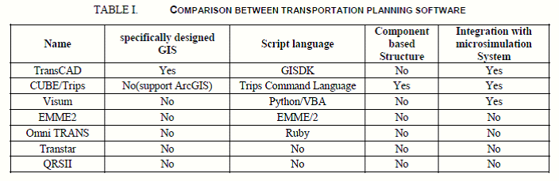

**Table 2.1: Comparison between transportation planning software**

The widely used transportation planning software all have user-friendly GUI, and more and more transportation planning software support GIS.

**2.1 TransCAD system using GUI:**

TransCAD[8] is the only one with Geographic Information System (GIS) designed specifically for use by transportation professionals to manage transportation data. It is widely used in China, America and other countries around the world today.

Most of popular planning software can be easily extended by scripting language or macro script. Vissum and Omni use python and ruby which is widely used today. TransCAD, CUBE and Vissum are well integrated with micro simulation system. TransCAD can obtain traffic data from GPS. Few of them are designed based on component architecture, because most of them are designed decays ago or are updated from the old version.

"TransCAD 6.0” released on November 1, 2012:

TransCAD combines GIS and transportation modelling capabilities in a single integrated platform, providing capabilities that are unmatched by any other package. TransCAD can be used for all modes of transportation, at any scale or level of detail. TransCAD provides:

1. A powerful GIS engine with special extensions for transportation

2. Mapping, visualization, and analysis tools designed for transportation applications

3. Application modules for routing, travel demand forecasting, public transit, logistics, site location, and territory management

TransCAD has applications for all types of transportation data and for all modes of transportation, and is ideal for building transportation information and decision support systems. TransCAD runs on readily-available hardware under Microsoft Windows and embraces virtually all desktop computing standards. This has two important benefits:

1. You can acquire and install TransCAD at a much lower cost than any other integrated GIS and transportation modelling solution.

2. You don’t have to build custom applications or complicated data interchange modules to perform transportation analysis with GIS data.

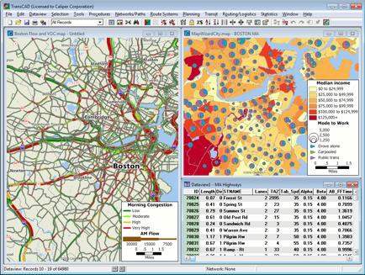

**Figure 2.1: TransCAD system using GUI**

**2.2 Adaptive traffic control system:**

The Adaptive Traffic Control System (ATCS)[9] is a personal computer based traffic signal control program which provides fully responsive traffic signal control based on real-time traffic conditions. ATCS automatically adjusts traffic signal timing in response to current traffic demands. ATCS is similar to the Urban Traffic Control System (UTCS) but goes beyond the limitations of UTCS to provide a traffic adaptive system of control. This is done by allowing ATCS to simultaneously control all three critical components of traffic signal timing, namely cycle length, phase split and offset. Adaptive Traffic Control System receives information from vehicle such as position and speed and then it is utilized to optimize the traffic signal. The system specifies the use of onboard sensors in vehicle and standard wireless communication protocol specified for vehicular applications as shown in Figure 2.2

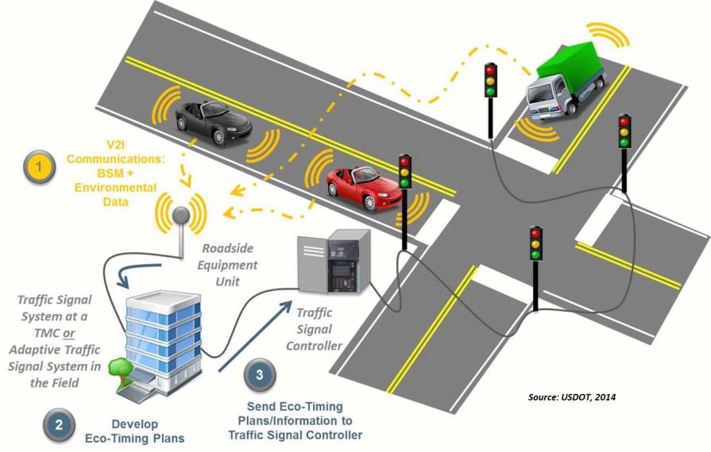

**Figure 2.2: Standard wireless communication protocol specified for vehicular applications**

**2.3 An Intelligent Secure Traffic Management System Based On Vanet**

Intelligent traffic system for VANET suggests creation for smart city framework for VANET consisting of Intelligent Traffic Lights which transmit warning messages and traffic statistic. In that system various Routing Protocol has been discussed and compared. They suggest that AODB is best suited for Intelligent Traffic Light[5]. Author suggests in reference [6] the data forecasting model for transmitting data from one to other. This article studied about the dynamic traffic control system and based on radio propagation model for predicting path loss and link.

The author suggests in reference [10] Intelligence road Traffic signalling system. In that system OBUs are used. OBUs used destination information for calculating load traffic on road for reducing the conjunction on road. The general belief is that it is more difficult to estimate and predict traffic density than traffic flow. The VANET architecture provides an excellent framework to develop an advanced road traffic signalling system. First formulate the vehicular traffic signal control problem as a job scheduling problem on processors, with jobs corresponding to platoons of vehicles. Under the assumption that all jobs are equal size, By using an online algorithm, which referred to as the oldest job first (OJF) algorithm ,to minimize the delay across the intersection.

The OJF algorithm is 2-competitive ,implying that the delay is less than or equal to twice the delay of an optimal offline schedule with perfect knowledge of the arrivals .It show that ,how a VANET is used to group vehicles into approximately equal-sized platoons ,which can then be scheduled using OJF .The two-phase approach are used ,where first approach is to group the vehicular traffic into platoons and then apply the OJF algorithm, i.e., the oldest arrival first (OAF) algorithm. Our simulation(NS2) results shows that, under light and medium traffic loads, the OAF algorithm reduce the delay experienced by vehicles as they pass through the intersection, as compared with vehicle-actuated methods, Webster’s method, and pre-timed signal control methods. Under heavy vehicular traffic load, the OAF algorithm performs the same as the vehicle actuated traffic method but still produces the lowest delay, as when compared with Webster’s method and the pre-timed signal control method.

**2.3.1 VANET definition:**

A Vehicular Ad-Hoc Network, or VANET, is a form of Mobile ad-hoc network, to provide communications among nearby vehicles and between vehicles and nearby fixed equipment, usually described as roadside equipment. The main goal of VANET is providing safety and comfort for passengers. To this end a special electronic device will be placed inside each vehicle which will provide Ad-Hoc Network connectivity for the passengers.

This network tends to operate without any infra-structure or legacy client and server communication. Each vehicle equipped with VANET device will be a node in the Ad-Hoc network and can receive and relay others messages through the wireless network.

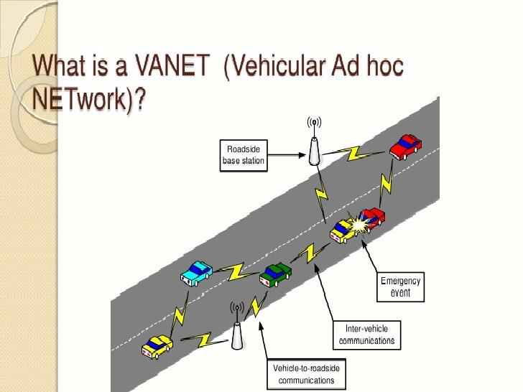

**Figure 2.3: VANET**

Collision warning, road sign alarms and in place traffic view will give the driver essential tools to decide the best path along the way. Vehicular Ad Hoc Networks (VANET) are a form of MANETs used for communication among vehicles and between vehicles and roadside equipment shown in Figure 2.3

**2.4 Priority based traffic lights controller using wireless sensors**

Priority Based Traffic Lights Controller Using Wireless Sensor Network[11], the author implements Adaptive Traffic control System based on (WSN) wireless sensor network. In that system, time manipulation is used for controlling traffic light. This system control traffic over multiple intersections. As such, it is becoming very crucial to device efficient, adaptive and cost-effective traffic control algorithms that facilitate and guarantee fast and smooth traffic flow that utilize new and versatile technologies. An excellent potential candidate to aid on achieving this objective is the Wireless Sensor Network (WSN). Many studies suggested the use of WSN technology for traffic control. In, a dynamic vehicle detection method and a signal control algorithm to control the state of the signal light in a road intersection using the WSN technology were proposed. In the that project, two junctions are discussed and brought into focus along with the use of wireless sensors as many studies suggest the use of sensors. If there is no traffic lights control system in these junctions, huge amount of traffic causes waiting time and accidents. As a result, physical existence of traffic police is always required there which is inappropriate due to availability of technology today. Also, due to heavy traffic in these two junctions, emergency vehicles face hardships when they pass from there. Sensors will be located at a specific distance before the junctions which will detect the speed and sound waves of siren at a particular threshold. Based on the speed, sensors will communicate wirelessly with the traffic control system of the two junctions while realizing their routes. On the basis of WSN traffic control systems of the two junctions will be able to minimize the traffic flow by inter communication thus assigning the right time for red and green lights so that emergency vehicles can pass quickly. A WSN is used as a tool to instrument and control traffic signals roadways, while an intelligent traffic controller is developed to control the operation of the traffic infrastructure supported by the WSN. Simulation results show the efficiency of the proposed scheme in solving traffic congestion in terms of the average waiting time and average queue length on the isolated (single) intersection and efficient global traffic flow control on multiple intersections.

**2.5 Density Based Intelligent Traffic Signal System Using PIC Microcontroller**

In this project, optimization of traffic light controller in a City using microcontroller done. The system tries to reduce possibilities of traffic jams, caused by traffic lights, to an extent. The microcontroller used in the system is PIC. The system contains IR transmitter and IR receiver which are mounted on the either sides of roads respectively. The IR system gets activated whenever any vehicle passes on road between IR transmitter and IR receiver. Microcontroller controls the IR system and counts number of vehicles passing on road. Microcontroller also store vehicles count in its memory. Based on different vehicles count, the microcontroller takes decision and updates the traffic light delays as a result. The traffic light is situated at a certain distance from the IR system. Thus based on vehicle count, microcontroller defines different ranges for traffic light delays and updates those accordingly. The system records vehicle count in its memory at user predefined recording interval on real time basis. This recorded vehicle count data can be used in future to analyze traffic condition at respective traffic lights connected to the system. For appropriate analysis, the recorded data can be down-loaded to the computer through communication between microcontroller and the computer. Thus administrator on a central station computer can access traffic conditions on any approachable traffic lights and nearby roads to reduce traffic congestions to an extent. In future this system can be used to inform people about different places traffic condition.

**2.6 Summary**

This chapter talks about the different generations of transportation planning softwares, popular transportation planning softwares and the approaches used for the same.